**Quiz**

**BY**

**Meera Sase**

**Prachi Phulari**

##### *Under the Guidance*

##### *of*

**Ms. M. G. Shelke**

**DEPARTMENT OF COMPUTER SCIENCE & ENGINEERING**

**Mahatma Gandhi Mission’s College of Engineering, Nanded (M.S.)**

**Academic Year 2020-21**

# ACKNOWLEDGMENT

We are greatly indebted to your Mini Project guide, **Ms. M.G.Shelke** for her able guidance, and we would like to thank for her help, suggessions and numerous helpful discussions.

We gladly take this opportunity to thank **Dr. Rajurkar A. M.** (Head of Computer Science and Engineering, MGM’s College of Engineering, Nanded). We are heartly thankful to **Dr. G.S. Lathkar** (Director, MGM’s College of Engineering, Nanded) for providing facilities during the progress of the seminar and for her kind guidance and inspiration.

Last but not least, we are also thankful to all those who helped directly or indirectly in the complete and successful development of this seminar.

**With Deep Reverence,**

**Prachi Phulari**

**Meera Sase TY [CSE-B]**

**ABSTRACT**

The **Computer Fundamentals Quiz Project** is an interactive learning system designed to assess and strengthen users’ basic knowledge of computer concepts. It includes key topics such as hardware, software, operating systems, memory, input–output devices, number systems, and general computing operations. Through a set of well-structured multiple-choice questions, the system provides an engaging platform where learners can test their understanding and receive instant feedback, helping them identify areas that need improvement.

This project aims to support students, beginners, and competitive exam aspirants by offering a simple, user-friendly, and effective self-assessment tool. With automated score calculation, easy navigation, and a smooth quiz flow, the system enhances the learning experience while promoting computer literacy. Overall, the project provides a comprehensive way to learn, revise, and evaluate essential computer fundamentals in an accessible and interactive manner.

.

**TABLE OF CONTENTS**

|  |  |
| --- | --- |
| **Acknowledgement** | **I** |
| **Abstract** | **II** |
| **Table of Contents** | **III** |
| **List of Tables** | **VI** |
| **Chapter 1. INTRODUUCTION** | **1** |
| 1.1 Introduction | 2 |
| **Chapter 2. LITERATURE SURVEY** | **6** |
| 2.1 Review of Existing Quiz System and Platforms | 7 |
| 2.2 Understanding User Interests and Requirements | 7 |
| 2.3 Data Collection and Analysis | 8 |
| **Chapter 3. PLATFORM FEATURES** | **10** |
| 3.1 Home Page | 10 |
| 3.2 Start Quiz Page | 13 |
| 3.3 Leaderboard Page | 16 |
| 3.4 About Page | 20 |
| 3.8 Contact Page | 26 |
| **Chapter 4. IMPLEMENTION AND EXPERIMENT RESULTS** | **30** |
| 4.1 Sign-in Page | 31 |
| 4.2 Sign- up Page | 36 |
| 4.3 Sign-in Page/ Sign- up Page | 37 |
| **Conclusion** | **42** |
| **References** | **43** |

**List of Figures**

|  |  |  |
| --- | --- | --- |
| **Figure No.** | **Name of Figure** | **Page No.** |
| 1.1 | Sequence Diagram | 2 |
| 1.2 | Class Diagram | 11 |
| 3.1 | Home Page | 14 |
| 3.2 | Start Quiz Page | 16 |
| 3.3 | General Knowledge Quiz page | 17 |
| 3.4 | Computer Fundamental Quiz Page | 20 |
| 3.5 | Computer Fundamental Mcq Quiz Page | 22 |
| 3.6 | Math Quiz Page | 24 |
| 3.7 | Leaderboard Page | 25 |
| 3.8 | About Page | 28 |
| 3.9 | Contact Page | 32 |
| 4.1 | Login page | 36 |
| 4.2 | Registration Page | 38 |
| 4.3 | Data Update Table |  |

***Chapter 1***

# INTRODUCTION

A quiz is an interactive assessment tool designed to evaluate a participant’s knowledge, understanding, and recall of specific subjects in an engaging and structured way. Quizzes typically consist of a series of questions that may be objective, multiple-choice, true or false, or descriptive in nature. They serve various purposes such as testing academic learning, enhancing memory, encouraging self-evaluation, and making the learning process more enjoyable. In educational environments, quizzes help students revis

e important concepts and measure their progress, while in digital platforms they offer a fun and competitive way to learn new topics.

# ****Introduction:****

# Quizzes are an engaging and interactive method of learning that combine knowledge, evaluation, and entertainment. Designed to test a participant’s understanding of a particular topic, quizzes serve as an effective tool for self-assessment as well as academic and competitive learning. A quiz encourages critical thinking, improves memory retention, and helps learners revise concepts in a structured and enjoyable manner. With the rise of digital education, online quizzes have become even more popular due to their accessibility, instant feedback, and user-friendly nature.This project focuses on creating a comprehensive quiz system that highlights different areas of knowledge while providing an enriched learning experience. Much like how the forts of Maharashtra stand as symbols of the region’s heritage, quizzes represent an important component of the educational process. Each quiz question, like each fort, carries unique value—testing concepts, strengthening understanding, and building confidence in learners. This project aims to design a quiz that is not only educational but also interactive and enjoyable, helping students and users enhance their knowledge in a fun and meaningful way.

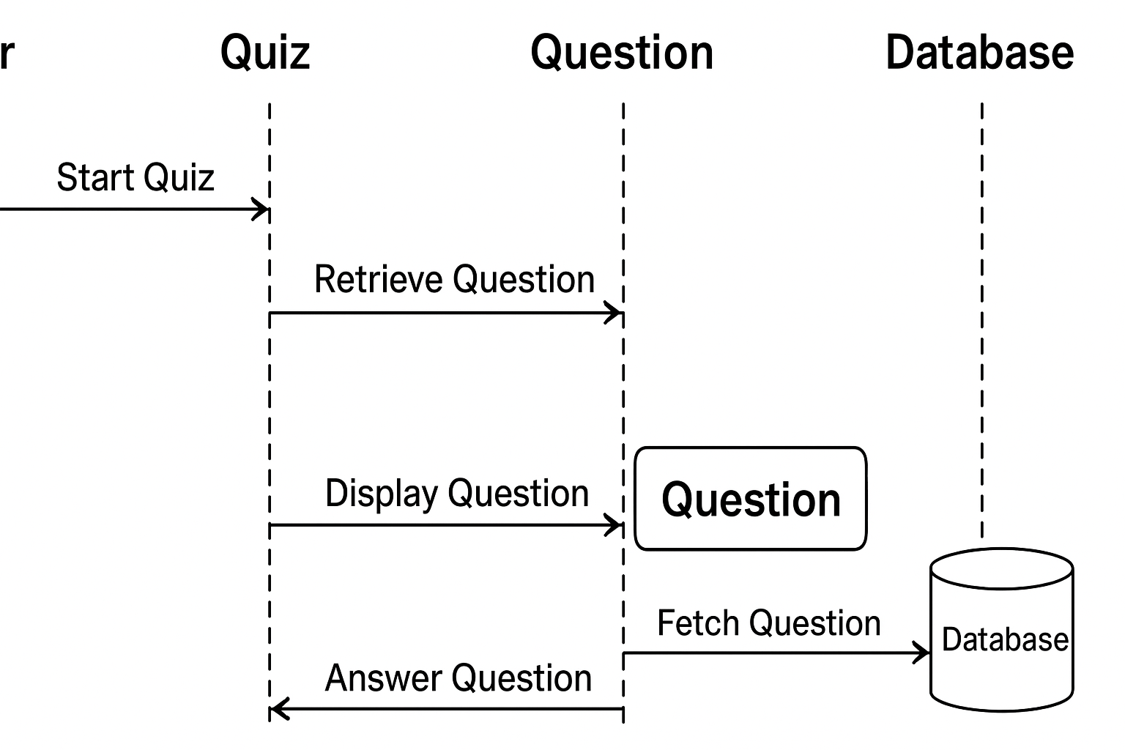

# Fig 1.1: Sequence Diagram

A **sequence diagram** is a UML diagram that explains how different parts of a system interact with each other in a step-by-step order over time. It focuses on the flow of messages between objects or components, showing who communicates with whom and in what sequence. Each participant in the system is represented at the top, and a vertical dashed line called a lifeline extends downward to represent the passage of time. Messages are shown as horizontal arrows that indicate the actions or requests being sent from one object to another. A return message, represented by a dashed arrow, shows the response from the receiver back to the sender. The diagram clearly illustrates the order of operations, making it helpful for understanding the flow of logic in login systems, payment processes, quiz attempts, and many other applications. It is widely used in system design because it helps developers identify the interaction flow, detect gaps, and understand how different components work together to complete a task.

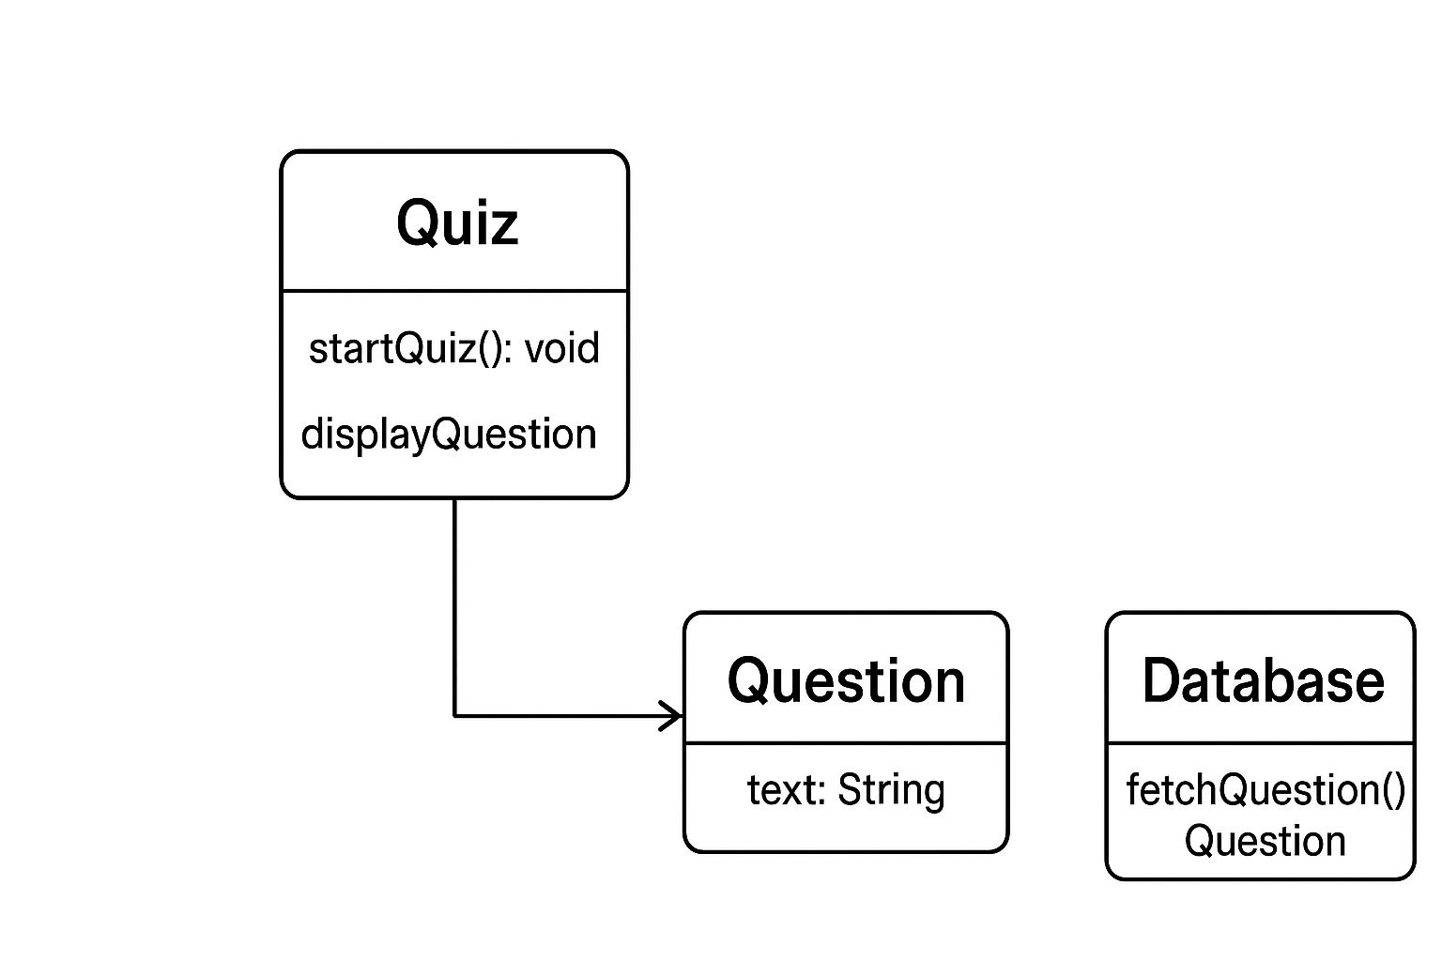

**Fig 1.2: Class Diagram**

# A ****class diagram**** is a UML diagram that describes the structure of a system by showing its classes, their attributes, methods, and the relationships between them. It works like a blueprint that explains how different parts of a software system are organized. Each class is represented as a box divided into three sections: the class name, the data it holds (attributes), and the operations it can perform (methods). Class diagrams also show relationships such as inheritance, association, aggregation, and composition, which explain how classes are connected or dependent on each other.

# 

# Fig 1.3: Class Diagram

A **state chart diagram** is a UML diagram that shows how an object or system changes its state in response to different events or actions. It focuses on the life cycle of an object, starting from its initial state, moving through various intermediate states, and finally reaching the end state. Each state represents a specific condition or situation of the system, while transitions (arrows) show how the system shifts from one state to another when an event occurs. State charts also include actions, decisions, and conditions that determine when a transition should happen.

***Chapter 2***

# ****2. LITERATURE SURVEY****

A quiz is one of the most widely used tools in education and skill assessment, offering an interactive and systematic method for evaluating a learner’s knowledge, comprehension, and problem-solving abilities. With the increasing use of technology in education, quizzes have evolved from traditional paper-based tests into dynamic, digital platforms accessible through web and mobile applications. Many existing quiz systems provide automated scoring, instant feedback, and user-friendly interfaces, making them suitable for students, teachers, competitive exam aspirants, and general knowledge learners. To develop an improved and efficient quiz system, it is important to analyze existing platforms, their features, and their limitations. This literature survey reviews popular quiz websites, learning apps, and educational systems to identify current trends, strengths, and gaps that the present project aims to address.

## ****2.1 Review of Existing Quiz Systems and Platforms (Detailed)****

## A wide range of quiz platforms exist today, including websites such as Kahoot, Quizizz, ProProfs Quiz Maker, Google Forms, and educational apps like BYJU’S, Unacademy, and Brainly. These platforms offer interactive quiz formats, colourful designs, and a wide variety of question types such as MCQs, true/false statements, fill-in-the-blanks, and timed challenges. Their strengths lie in features like instant scoring, real-time progress tracking, leaderboards, accessibility on mobile devices, and integration with online classrooms.

## However, most widely used platforms are either too generic or require paid features for advanced functionalities. For example, Kahoot and Quizizz provide gamified quizzes but limit customization in their free versions. Google Forms allows quiz creation but lacks interactive animations, gamification, and performance analytics. Many systems also require high-speed internet, which may not be feasible for all users. Furthermore, while large educational apps provide quizzes, they are often part of bigger learning modules and do not focus solely on quiz-based assessment.

## From a technical perspective, many smaller quiz websites rely on simple HTML, CSS, and JavaScript designs without dynamic databases. These systems use static questions, offering the same experience repeatedly, leading to reduced engagement. Only advanced platforms use backend tools like PHP, MySQL, Node.js, or frameworks like React and Angular to create dynamic quiz experiences with updated questions, user accounts, or analytics dashboards. This review shows that many existing quiz systems lack personalization, deep analytics, user-centered design, and full customization.

## ****2.2 Understanding User Interests and Requirements :****

## To design an effective quiz platform, it is essential to understand what users expect. Students prefer quizzes that are simple, visually appealing, and easy to navigate. They enjoy features like timers, hints, immediate explanations, and scoreboards that help them track their progress. Competitive exam aspirants look for detailed question sets, explanations, and difficulty levels. They require topic-wise categorisation, time-bound tests, and performance analytics that help identify weak areas.

Teachers and educators need systems that allow easy creation, editing, and management of quizzes. They also prefer tools that automatically evaluate answers, generate reports, and support multiple question types. General users enjoying GK or skill-based quizzes prefer appealing layouts, random question generation, and gamified elements like levels, rewards, badges, and streaks.

Modern users also show strong interest in mobile-friendly designs, dark mode, and accessibility features that make quizzes usable on any device. Social elements like sharing scores, competing with friends, and participating in live quiz challenges improve engagement. Therefore, a well-designed quiz platform must combine educational quality with fun, interactivity, and modern UI/UX features.

## ****2.3 Data Collection and Analysis (Detailed)****

The data for quiz questions and platform features was collected using various reliable sources. For subject-based quizzes like Computer Fundamentals, English Grammar, or General Knowledge, data sources include NCERT textbooks, reference books, academic websites, educational YouTube channels, and government exam syllabi. For broader topics, platforms such as Wikipedia, online MCQ banks, and educational forums were reviewed.

To analyze features of existing quiz platforms, both mobile apps and websites were studied. User reviews, feature lists, performance issues, and UI/UX patterns were examined through app stores, blogs, and online communities. This evaluation revealed common requirements such as clear navigation, attractive design, instant feedback, and secure data storage.

Additionally, technical analysis was carried out to compare static quiz systems with dynamic, database-driven models. It was observed that static quiz systems, though simple, do not allow randomization, performance tracking, or user accounts. Dynamic systems using PHP, MySQL, or JavaScript frameworks provide more flexibility, allowing administrators to add new questions, store user results, and generate analytics. This analysis helps define the structure of the present quiz project by combining academic accuracy with technological efficiency.

# *Chapter 3*

# PLATFORM FEATURES

The Quiz Platform is an interactive web-based application designed to make learning engaging, enjoyable, and effective for users of all age groups. The system provides a structured environment where users can test their knowledge across various subjects, topics, or categories through well-organized quiz modules. Built with a clean and intuitive user interface, the platform ensures smooth navigation, allowing users to easily access sections such as Home, Categories, Instructions, Quiz Play Area, Results, and Leaderboards. Each quiz is designed with carefully curated multiple-choice questions that not only test memory but also promote conceptual understanding. The platform emphasizes real-time interaction by instantly evaluating answers, displaying scores, and offering feedback to help learners track their progress Home Page.

**3.1 Home page:**

The homepage of the quiz website is carefully designed to provide users with a welcoming, visually appealing, and highly intuitive first interaction. At the top of the page, a sleek navigation bar with a dark background features essential menu options such as **Home**, **Start Quiz**, **Leaderboard**, **About**, and **Contact**, ensuring that users can effortlessly explore different sections of the platform. The primary banner occupies most of the screen and uses a vibrant teal background with educational-themed objects like pens, notebooks, magnifying glasses, and letter tiles. These elements not only enhance the aesthetic appeal but also reflect the educational and playful nature of the quiz platform. At the center of the screen, the bold heading **“Welcome to the Quiz!”** immediately captures attention, creating a sense of excitement and readiness for users who want to test their knowledge. Below this heading, a short and engaging description invites users to challenge themselves through an enjoyable and interactive quiz experience, emphasizing both learning and entertainment. The bright yellow **“login”** button placed just below the text acts as a strong visual cue, guiding new users to sign in quickly and begin participating. The overall design uses smooth shapes, soft gradients, and strategically placed elements to create a modern, clean, and friendly interface. This thoughtful layout helps build user trust, motivates participation, and ensures that even first-time users can navigate the site without confusion, ultimately enhancing the overall user experience.

At the center of the homepage, the bold heading **“Welcome to the Quiz!”** acts as the main focal point, supported by a short description encouraging users to “challenge your knowledge and test your skills,” emphasizing that the platform is not just informative but also interactive and enjoyable. The bright yellow **login button**, placed prominently underneath, enhances usability by drawing immediate attention and guiding new users to begin their journey with minimal effort. This button also supports clear call-to-action design principles, helping convert visitors into participants.

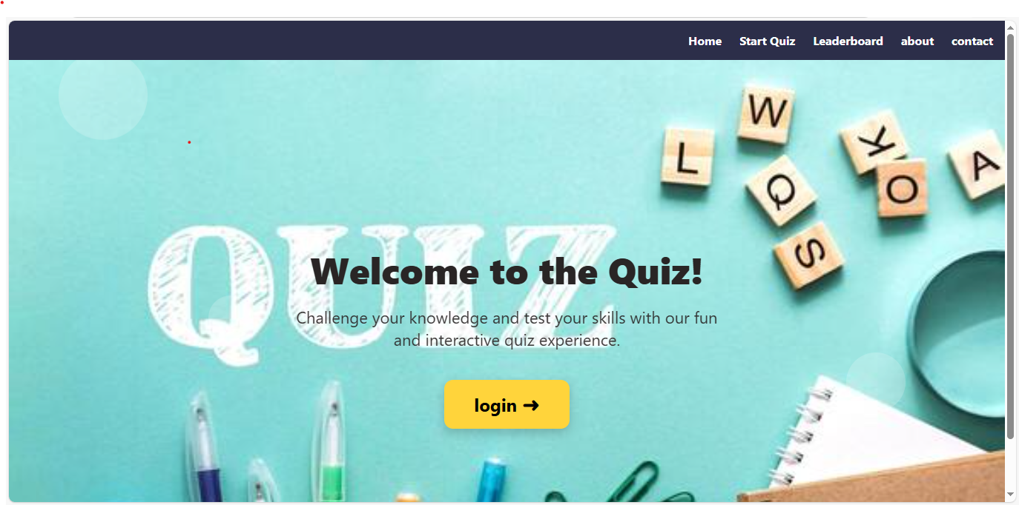

**Fig 3.1: Home Page**

**3.2 Start Quzi page:**

The quiz category selection page is designed with a clean, structured, and visually engaging layout to help users easily choose the type of quiz they want to attempt. At the top, a bold and glowing heading titled **“Select a Quiz Category”** immediately informs users about the purpose of the page, ensuring clarity and smooth navigation. The background features soft circular shapes and a rich blue gradient, giving the interface a modern and calming 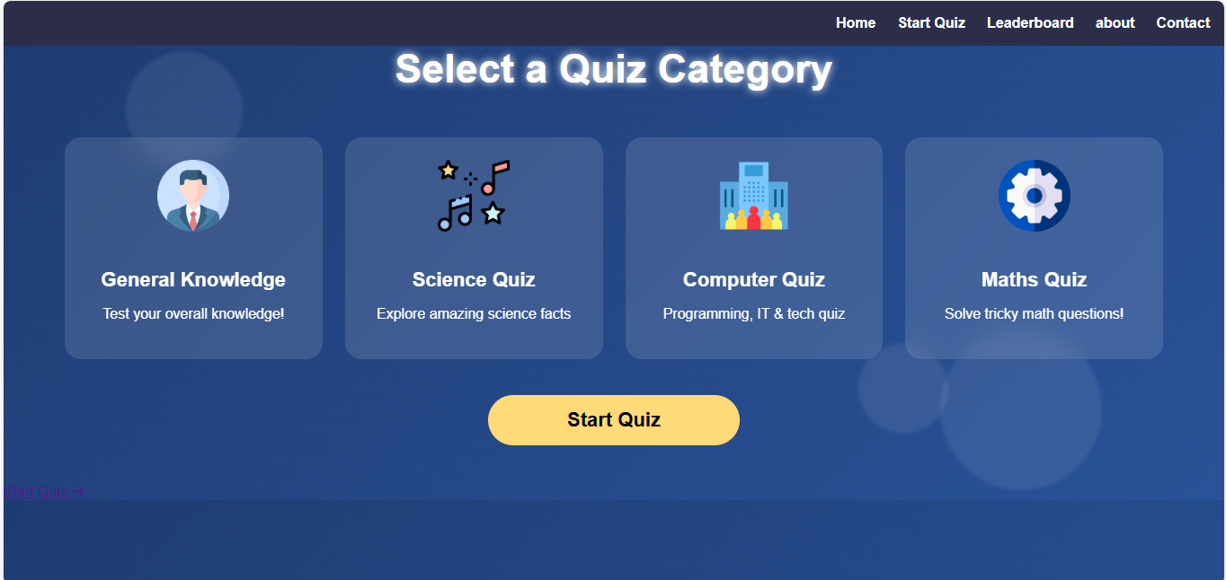

### Fig.3.2 Start Quiz Page

The quiz category selection page is designed with a clean, structured, and visually engaging layout to help users easily choose the type of quiz they want to attempt. At the top, a bold and glowing heading titled **“Select a Quiz Category”** immediately informs users about the purpose of the page, ensuring clarity and smooth navigation. The background features soft circular shapes and a rich blue gradient, giving the interface a modern and calming appearance. Four neatly arranged category cards are placed at the center of the page, each representing a different quiz type—**General Knowledge, Science Quiz, Computer Quiz, and Maths Quiz**. Each category card includes an attractive icon that visually reflects the subject, along with a short descriptive subtitle that helps users understand what to expect from that quiz. The quiz question interface is designed with a clean, focused, and user-friendly layout to ensure that users can answer questions without distractions. At the center of the page, a well-structured quiz card with rounded corners and soft shadows stands out against a dark blue background, giving the interface a modern and premium look. The header inside the card clearly highlights the selected quiz topic as **“History Quiz”**, accompanied by a small icon that visually represents the subject, helping users stay aware of the category they are attempting. Below the title, the question is displayed in bold and readable text—in this example, **“Who was the first Mughal Emperor of India?”**—ensuring clarity and easy comprehension. Each answer option is presented in an individual button-style layout with radio inputs, allowing users to select only one correct answer.

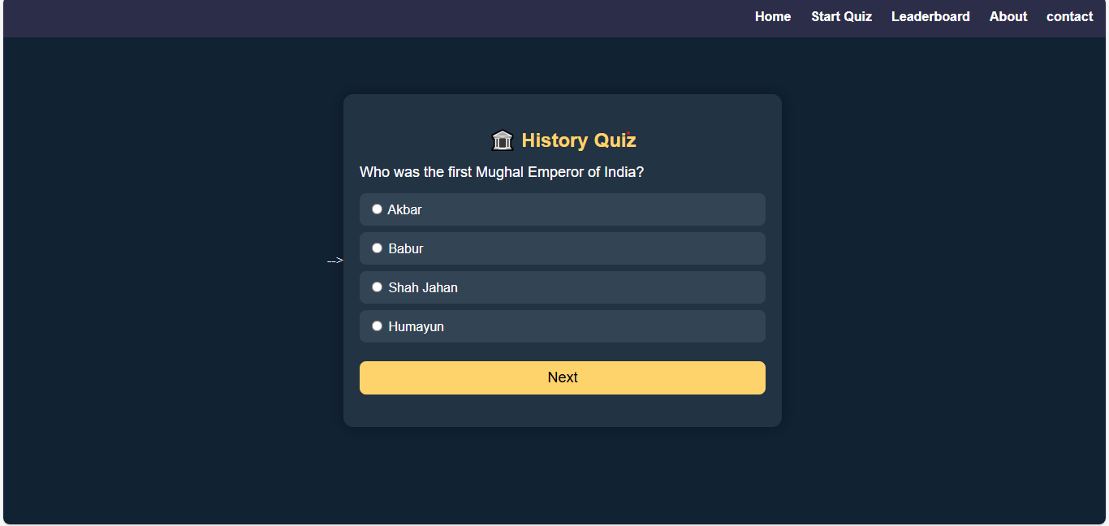

**Fig 3.3: General Knowledge Quiz Page**

The “Science Quiz Categories” page is designed with a visually appealing and user-friendly interface that helps learners explore different branches of science with ease. At the top, a glowing and bold heading titled **“Science Quiz Categories”** clearly introduces the section, ensuring that users immediately understand the purpose of the page. The background features a smooth blue gradient with soft circular overlays, creating a calm, scientific atmosphere that aligns with the educational theme. Four neatly arranged category cards—**Physics, Chemistry, Biology, and Space Science**—are displayed prominently in the center, each represented with an intuitive and subject-appropriate icon. These icons visually communicate the essence of each scientific field, making the categories instantly recognizable even at a glance. Beneath each category title, short descriptions such as “Motion, energy, forces & more” or “Elements, reactions & compounds” provide quick insights into the type of questions users can expect, helping them choose the category that best matches their interest or knowledge area. The cards feature rounded corners, balanced spacing, and soft shadows, giving the page a modern, polished, and organized appearance. At the bottom, a large yellow **“Start Quiz”** button acts as the primary call-to-action, guiding users to begin the quiz journey after selecting their desired science topic. The high contrast of the button ensures easy visibility and accessibility. Overall, the page combines smooth design aesthetics with clear navigation, making it simple and enjoyable for users to explore different scientific domains and begin testing their knowledge.

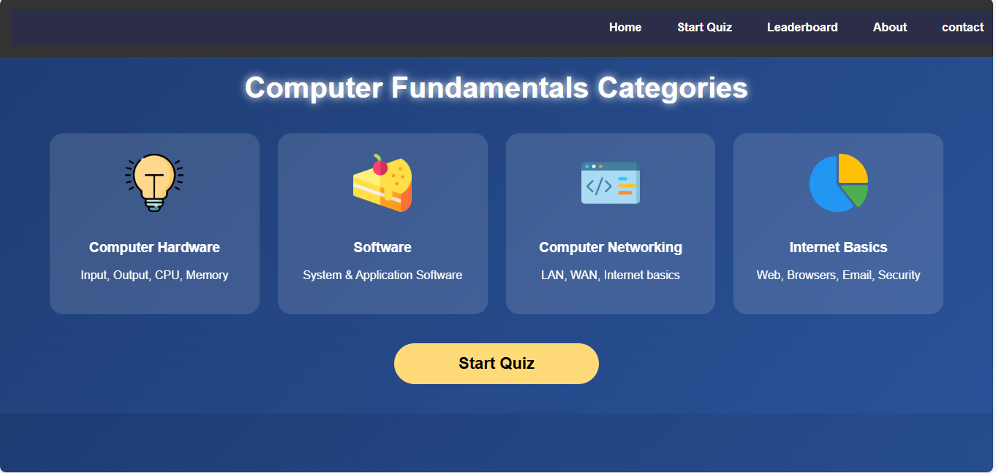

**Fig 3.4:Computer Fundamentals Quiz Page**

The Software Quiz interface is designed with a clean and modern layout to provide users a smooth quiz-taking experience. At the top of the page, a fixed navigation bar displays essential links like Home, Start Quiz, Leaderboard, About, and Contact, allowing users to move easily between different sections of the platform. The navigation bar uses a subtle dark theme that blends consistently with the overall color scheme of the page, promoting both usability and visual harmony.At the center of the screen, a rounded rectangular quiz card is prominently displayed. This card uses a soft shadow and slightly lighter background color to stand out against the darker page background, naturally drawing the user’s focus to the quiz content. At the top of the card, the title **“Software Quiz”** is shown with a small laptop icon, clearly indicating the topic of the current quiz section. This thoughtful visual cue helps learners instantly recognize that the questions relate to computer software fundamentals.Below the title, the question “Which of the following is system software?” is presented in a simple, readable font. Under the question, four answer options—MS Word, Windows OS, Tally, and Chrome—are displayed as individual button-style boxes with radio buttons. Each option is neatly aligned, with a padded rectangular background to ensure clarity and ease of selection. The consistent spacing and uniform design of the answer buttons improve readability and help reduce user confusion during the quiz. At the bottom of the quiz card, a large, attractive **Next** button is highlighted in a bright yellow shade. This color choice ensures that the action button stands out, guiding users to proceed to the next question once they select an answer. The button’s placement and size enhance usability, especially for users navigating on touch devices . The entire page uses a dark, clean, and distraction-free environment to keep the user focused on answering the quiz questions. The minimalistic design, coupled with responsive alignment, ensures the quiz interface works smoothly across different devices and screen sizes. Overall, this Software Quiz interface is simple, intuitive, visually appealing, and highly user-friendly, making it ideal for learning and assessment activities.

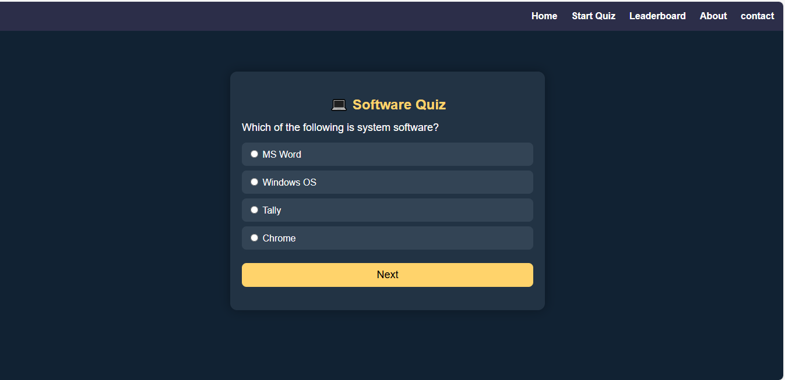

**Fig 3.5: Computer Fundamentals mcq Quiz Page**

The Math Quiz Categories interface is designed to provide an engaging and structured learning experience for students exploring different areas of mathematics. At the top of the page, a sleek navigation bar displays essential links such as Home, Start Quiz, Leaderboard, About, and Contact, allowing users to navigate seamlessly across the platform. The dark-colored header blends smoothly with the overall theme and ensures consistent visual flow throughout the interface.

z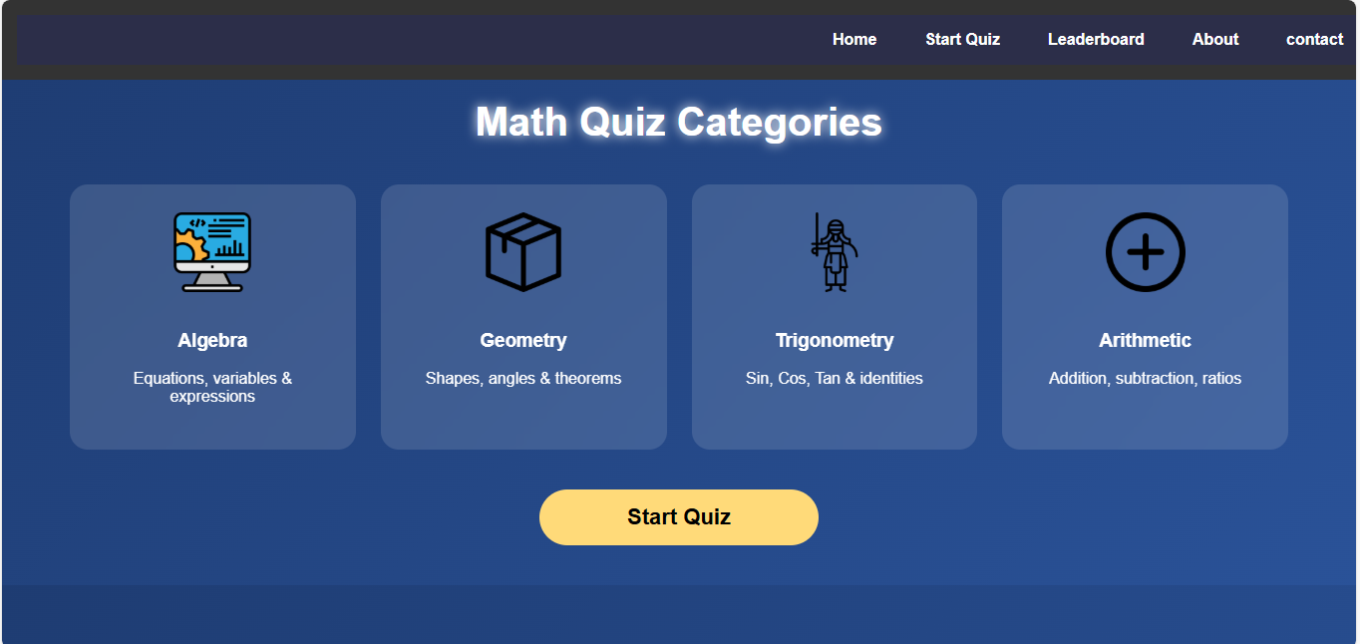

**Fig 3.6: Math Quiz Page**

The image shows a clean and modern web-based **Trigonometry Quiz** interface designed with a dark theme. At the top of the page, there is a navigation bar containing links such as Home, Start Quiz, Leaderboard, About, and contact, all aligned to the right on a dark navy background. The main content is centered on the page inside a rounded rectangular quiz card with a slightly lighter dark-blue shade. At the top of this card, a small triangular icon appears beside the bold yellow title “Trigonometry Quiz.” Below the title, the question “What is sin(90°)?” is displayed, followed by four multiple-choice answer options. Each option is presented inside a dark blue button-like container with a radio button on the left; the choices include **0**, **1**, **√3/2**, and **1/2**. At the bottom of the quiz box, there is a wide yellow button labeled “Next,” which the user would click to move to the next question

**3.3 Leaderboard Page**

The image displays a stylish and well-organized **Leaderboard** page from a quiz or scoring website, designed with a sleek dark-purple gradient background. At the top of the screen, a navigation bar appears with links such as Home, Start Quiz, Leaderboard, about, and Contact, all aligned to the right and presented in white text for clear visibility. The word **Leaderboard** is prominently centered near the top in large, glowing white text, giving it a standout visual effect. Below this heading is a rounded rectangular leaderboard table with a semi-transparent purple panel. The table is divided into three main columns: **Rank**, **Player Name**, and **Score**, each labeled at the top in bold white text.The ranking section uses medal icons to represent the top three positions—gold for first place, silver for second, and bronze for third—adding a visually appealing and intuitive ranking system. The first row shows Aarav in the top position with a score of **95**, followed by Priya in second place with **90**, and Rohan in third place with **87**. Below the medal positions, the remaining ranks (4, 5, and 6) are listed numerically without icons: Sneha with **82**, Abhi with **78**, and Meera with **74**. The layout uses soft glowing highlights and smooth gradients, creating a polished and modern UI design that clearly emphasizes player rankings and scores while maintaining a visually engaging aesthetic.

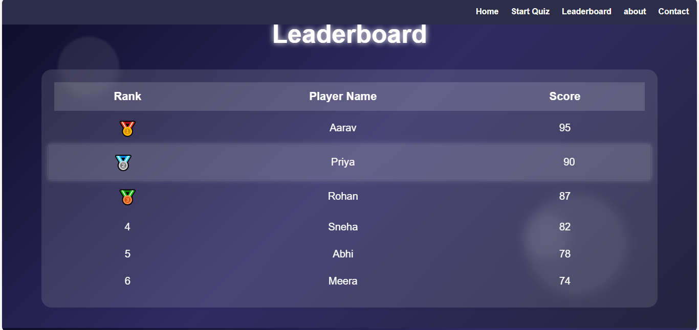

**Fig 3.7: Leaderboard Page**

The image shows a polished and visually appealing **Leaderboard page** designed with a dark, elegant theme. At the very top, there is a navigation bar with options such as Home, Start Quiz, Leaderboard, about, and Contact, all aligned to the right side in clean white text. This navigation bar stands out against a darker background, making it easy for users to access different sections of the website.

**3.4 About Page**

The image displays a well-designed **About Us** page from an interactive quiz platform, presented with a smooth blue gradient background that gives the layout a clean and modern appearance. At the top of the page, the navigation bar is positioned on the right side and includes menu links such as Home, Start Quiz, Leaderboard, About, and contact, all written in white text for clear visibility. Beneath this navigation bar, the title **“About Us”** **“We create interactive quizzes for smarter learning.”** This sentence summarizes the platform’s mission in a simple and engaging way. The image displays a well-designed About Us page from an interactive quiz platform, presented with a smooth blue gradient background that gives the layout a clean and modern appearance. At the top of the page, the navigation bar is positioned on the right side and includes menu links such as Home, Start Quiz, Leaderboard, About, and contact, all written in white text for clear visibility. Beneath this navigation bar, 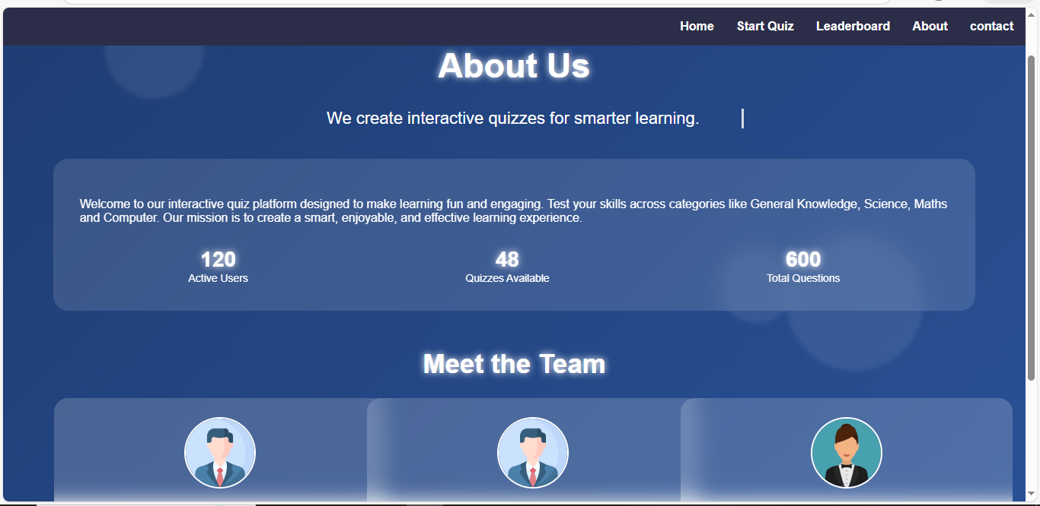

**Fig 3.8: About Page**

Centered below the navigation bar is the main title **“About Us”**, displayed in large, bold, glowing white text that stands out and immediately captures attention. Directly beneath this heading is a tagline that reads **“We create interactive quizzes for smarter learning.”** This short line clearly communicates the purpose and vision of the platform, emphasizing the idea of making learning more engaging through interactive tools.

A large rectangular information box with soft, rounded corners sits below the tagline. This box has a semi-transparent, lighter blue overlay that gently contrasts with the background, helping the content inside stand out. The text inside this box welcomes users to the platform and explains that it is designed to make learning enjoyable, engaging, and effective. It also highlights that the platform offers quizzes across different subjects, including General Knowledge, Science, Maths, and Computer. The mission statement emphasizes creating a smarter and more interactive learning experience for users.

**3.4 Contact Page**

The **Contact** page follows the same clean, modern, and visually appealing design style as the rest of the quiz platform, using a smooth blue gradient background that creates a calm and welcoming atmosphere. At the top of the page, the familiar navigation bar appears with links such as *Home*, *Start Quiz*, *Leaderboard*, *About*, and *Contact*, allowing users to easily switch between sections. Centered below the navigation bar is the glowing white heading **“Contact Us”**, designed to immediately capture attention. Beneath the heading is a short introductory message encouraging users to reach out for support, feedback, or general inquiries.

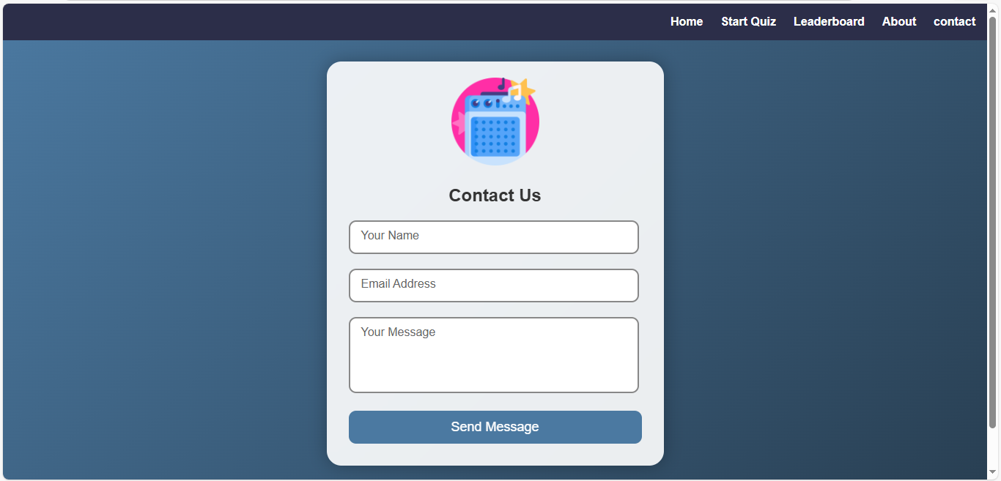

**Fig 3.9: Contact Page**

Here’s a **highly detailed descriptive paragraph** for a Contact page, written in the same level of detail as your About Us page:

The **Contact Us** page of the interactive quiz platform is designed with the same sleek and modern visual style as the rest of the site, featuring a smooth gradient blue background that conveys a professional yet inviting atmosphere. At the top, the familiar navigation bar is positioned on the right side, containing menu links such as *Home*, *Start Quiz*, *Leaderboard*, *About*, and *Contact*, all in crisp white text to ensure readability and easy navigation. Centered prominently beneath the navigation bar is the page title **“Contact Us”**, displayed in large, glowing white text that immediately draws the user’s attention and clearly communicates the purpose of the page. Directly below the title, a brief introductory sentence invites users to reach out for support, suggestions, or inquiries, emphasizing the platform’s dedication to accessibility and responsive communication.

The main content is contained within a large, rounded rectangular panel with a semi-transparent blue overlay that contrasts subtly with the background, creating a clear and visually distinct area for user interaction. Inside this panel, a structured **contact form** is presented, including input fields for **Full Name**, **Email Address**, and a

***Chapter 4***

# IMPLEMENTATION DETAILS AND EXPERIMENTAL RESULT

The implementation of the project "Forts of Maharashtra" involved the development of a digital platform that provides users with comprehensive information about the historical forts located throughout the state. The project was structured using a client-server architecture to ensure scalability and ease of access. The frontend of the application was developed using HTML, CSS, and JavaScript, with the option to enhance user experience through a modern JavaScript framework such as React. The backend was built using Node.js with the Express framework, enabling robust server-side operations and API management. All fort-related data, such as names, locations, historical significance, and images, were stored in a structured database using MongoDB. This database design allowed for flexible data retrieval and easy integration with the frontend via RESTful APIs.The system was divided into several key modules. The homepage presented an introduction to the cultural and historical importance of Maharashtra’s forts, offering an intuitive navigation menu for easy access to other parts of the application. The Fort Directory module displayed a list of forts with thumbnail images and basic information. Users could click on any fort to view a dedicated page with detailed content including history, architectural features, and travel information. A search and filter feature was implemented to help users find forts by name, district, or type (e.g., hill fort, sea fort, jungle fort). An optional admin panel was also created to allow authorized users to add, edit, or delete fort entries, thus making the system dynamic and easily maintainable.

## sign-in Page

The image depicts a mobile webpage interface for a site named "Forts of Maharashtra", which appears to be an informational or tourism-related portal focused on the historical forts in the Indian state of Maharashtra. At the top of the page, there is a navigation bar with links labeled Home, Service, About, and Contact, suggesting the site provides various services and information related to the forts.

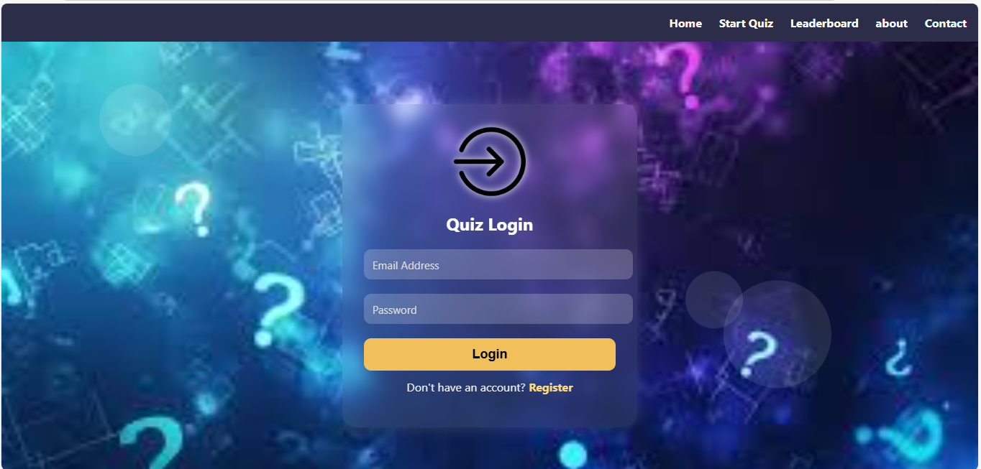

**Fig 4.1: Login Page**

Overall, this is a clean, user-friendly login interface for a mobile web application centered around exploring forts in Maharashtra, providing easy access and navigation for both new users (via Sign Up) and returning users (via Login). The image shows a mobile web application interface for a site titled "Forts of Maharashtra", which is likely designed to provide information about various historical forts located in the Indian state of Maharashtra. The layout and structure of the page follow a standard user authentication design, featuring a login form that is commonly used in web and mobile applications.At the top of the page, there is a navigation bar with a dark background. This navigation bar includes the website title "Forts of Maharashtra" on the left and several menu options on the right — Home, Service, About, and Contact. These links indicate that the website is likely structured to provide:

## Sign-up page

The image depicts the "Sign Up" page of a mobile web application for a site titled "Forts of Maharashtra". This page is part of a user authentication system, specifically designed to register new users on the platform. The clean and simple user interface ensures ease of use, especially on mobile devices.

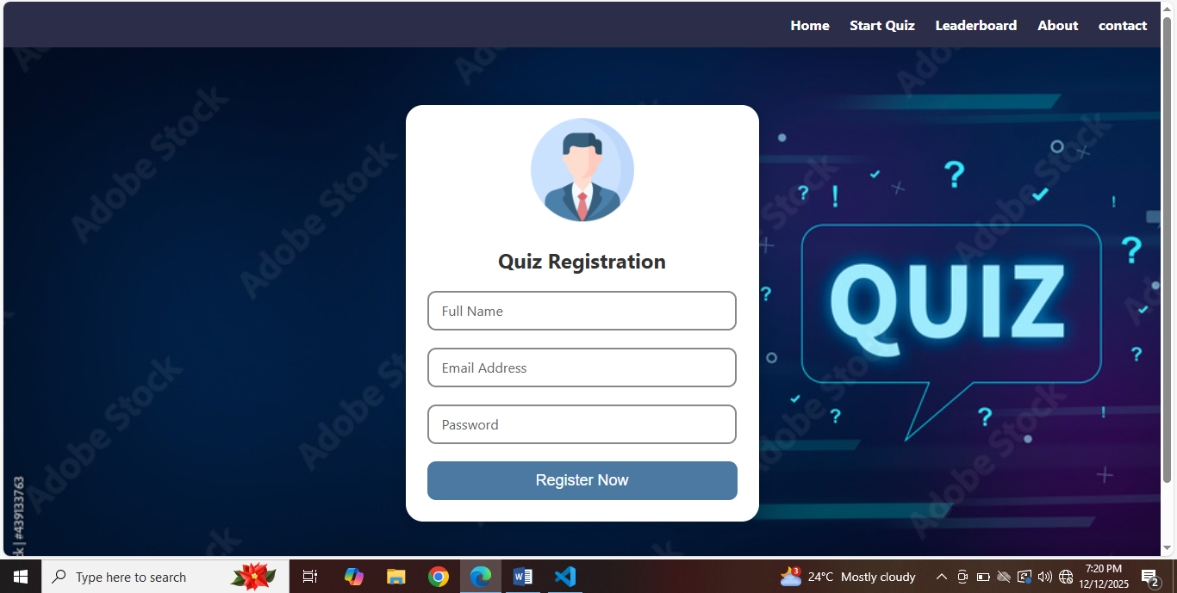

**Fig 4.2: Registration Page**

## Sign in / sign up

The Database Implementation for the Forts of Maharashtra project is designed to efficiently manage user information and ensure seamless access to the website. At the core of this design is the users table, which stores all essential details required for user registration and authentication. The table includes fields such as id, serving as a unique, auto-incremented primary key for identifying each user, and fullname, which captures

z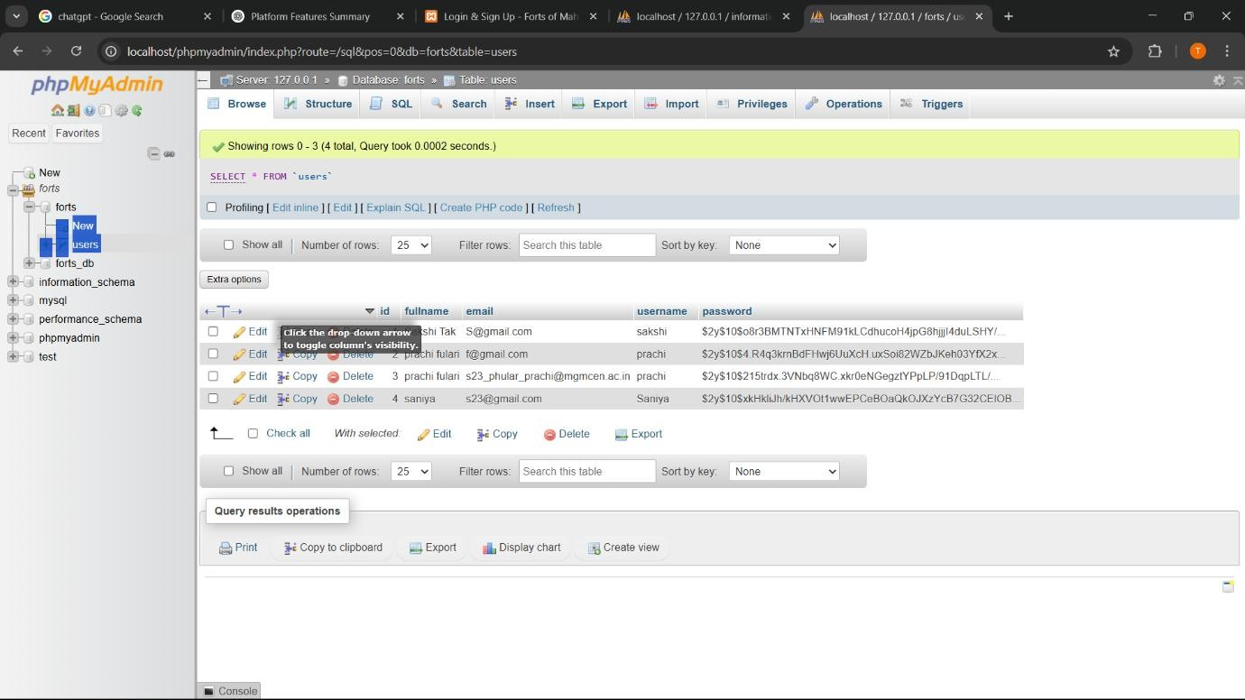

* 1. **Data Upadate Table**

The user’s full name for personalization across the site. The email and username fields are used to enable secure and convenient user access, with the email serving as a unique identifier for account creation and the username providing an easy login option. To protect sensitive information, the password field is securely stored using a strong hash algorithm, ensuring that user credentials remain safe and encrypted. This design allows for robust user account management, making it a fundamental component of the site’s database structure. Together, these fields enable a secure, user-friendly experience for site visitors, allowing seamless interaction with the platform and its heritage-focused services**.**

## CONCLUSION

The quiz platform represents a well-designed, interactive, and user-centric approach to learning, effectively combining technology, education, and engagement. Its clean, modern interface with smooth gradient backgrounds, glowing headings, and rounded content sections creates a visually appealing environment that encourages prolonged user interaction. The platform’s navigation is intuitive, with clearly labeled menus such as Home, Start Quiz, Leaderboard, About, and Contact, ensuring users can seamlessly move between sections without confusion.The quiz functionality itself is highly effective for knowledge assessment and skill improvement, offering multiple-choice questions across various subjects such as General Knowledge, Science, Mathematics, and Computers. The inclusion of real-time scoring, a dynamic leaderboard, and progress statistics adds motivation and competitiveness, fostering a sense of achievement among users. The About Us and Meet the Team sections build credibility and trust by humanizing the platform, while the Contact page ensures accessibility and support, allowing users to provide feedback or seek help easily.

Overall, the platform successfully balances aesthetics, usability, and educational value. It not only engages learners but also provides measurable outcomes through quizzes and performance tracking. The combination of interactive design elements, informative content, and responsive support demonstrates the platform’s commitment to creating an enriching learning experience. In conclusion, this quiz platform stands out as a comprehensive tool for interactive learning, promoting knowledge retention, user engagement, and continuous improvement in a structured yet enjoyable way.

# 